## Electrochromic Windows

### Author

* Andrew Parker, NREL

### Description

Electrochromic windows are windows whose light transmittance can be changed from clear to very dark at will. These windows may save energy and reduce peak demand by decreasing unwanted solar gains.

### Modeler Description

Each window in the building is assigned a thermochromic window construction and a shading control. The shading control is set to increase the window tint to meet the daylighting setpoint in the zone. If the zone already has daylighting controls, the setpoints from those controls are used. If the zone does not have controls, new controls are added at the center of the zone with a setpoint of 500 lux. These controls are only used for changing the window tint; they are not used to control the interior lighting.

### Use Case Types

Retrofit, New Construction

### Arguments

“run_measure” is a choice argument that determines whether or not the Measure is applied during a given run.

### Initial Condition Message

### Final Condition Message

The number of zones and windows in those zones that were assigned thermochromic windows.

### Not Applicable Messages

Not applicable if no zones with windows were found in the model.

### Warning Messages

Warn if a zone is found but the zone centroid cannot be found (for placement of a new daylight sensor).

### Information Messages

List each zone that has a daylighting control already, or has one added to control the windows.

### Error Messages

### Code Outline

* Loop through all zones in the model
  + If a zone has daylighting controls
    - Put the zone into a list
  + If not
    - Add a new daylighting control with a setpoint of 500 lux that doesn’t control any of the interior lighting, just the windows.
* Loop through all subsurfaces
  + Get their surface
  + Get that surface’s zone
  + If the zone is in one of the lists from above
    - Add a WindowProperty:ShadingControl object with Shading Type = SwitchableGlazing and Shading Control Type = MeetDaylightIlluminanceSetpoint and assign it to this window
    - Assign the electrochromic window construction to this window

### Tests

**This measure applies to:**

1. Large Office
2. Medium Office
3. Primary School
4. Secondary School
5. Large Hotel
6. Hospital
7. Small Office
8. Stand-Alone Retail
9. Strip Mall
10. Supermarket
11. Quick Service Restaurant
12. Full Service Restaurant
13. Small Hotel
14. Outpatient Healthcare
15. Warehouse
16. Midrise Apartment

### Test results

The control strategy is to tint the windows to attempt to meet the daylight control setpoint. In this case, 500 lux. Sometimes the sun is too bright and direct, and the setpoint is exceeded even at full tint.

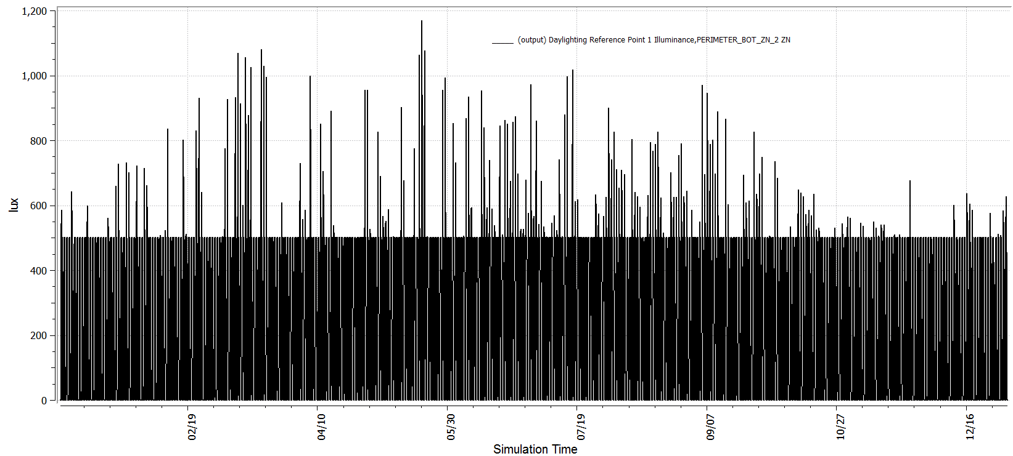

The result of this control strategy is that the model with electrochromic windows (black) has less solar radiation being transmitted through the windows than the model with normal windows (blue).

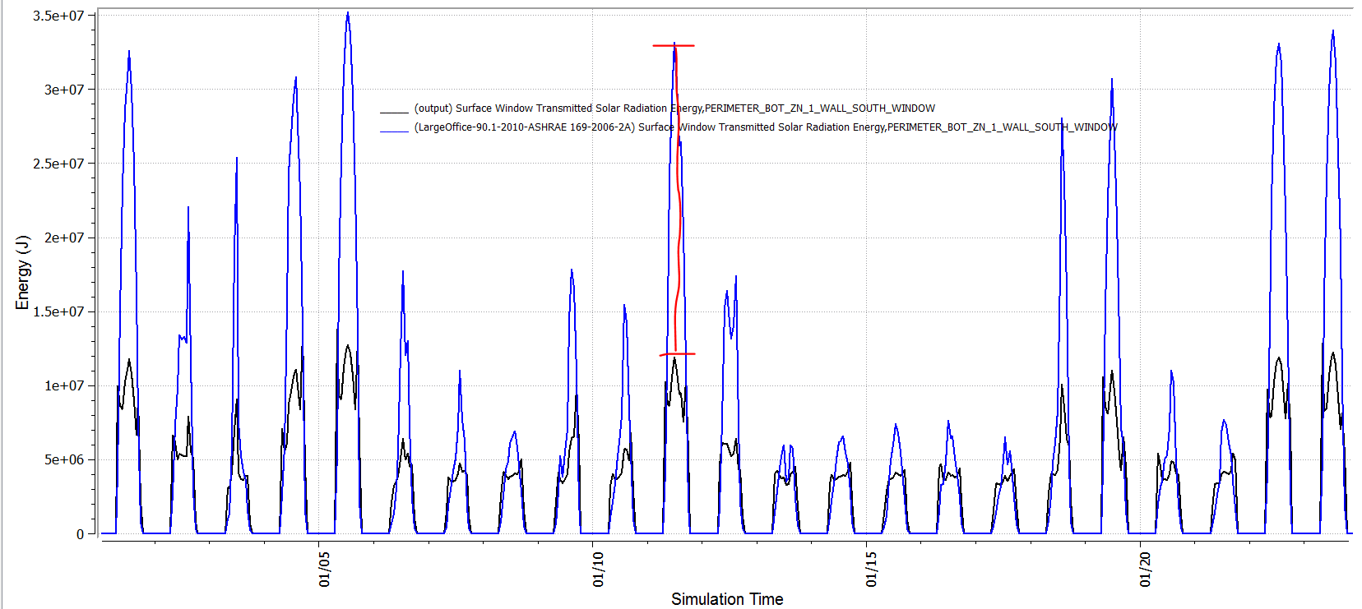

### References

1. <https://windows.lbl.gov/comm_perf/electrochromic/refs/LBNL-54966.pdf>